

Curriculum Policy

Content, Provision and Approach

(Local Policy)

Bankside College
Bankside College is a specialist educational setting for young adults aged 16–25 with autism and other learning difficulties. Many of our students have experienced significant trauma, disrupted education, and barriers to learning. Every student has an Education Health and Care Plan (EHCP), and for many, this is their first formal education in years.
We are proud to offer a safe, nurturing environment where students can rediscover their potential. Our curriculum is personalised, aspirational, and rooted in our values of growth, resilience & respect. These values shape every interaction, every lesson, and every decision we make.
Bankside College Curriculum Intent
Bankside College is part of Options Autism and reflects the organisation’s vision, mission, and promise:
- Vision: We build incredible futures by empowering vulnerable children and young adults in the UK to be happy and make their way in the world.
- Mission: Every day we improve the lives of those we educate and look after, their families and communities through a relentless focus on learning and caring.
- Promise: We are kind to each other… we work together… and we make things happen.
Our curriculum intent builds on this foundation:
Through enacting our values of growth, resilience & respect our vision is to create a safe and supportive environment where every young person feels valued, builds confidence, achieves their potential, and develops the skills needed to succeed in life.
We aim to:
- Personalise learning to meet individual needs and strengths.
- Prepare students for independent living, employment, and community inclusion.
- Foster positive relationships and emotional resilience.

Bankside College Curriculum Implementation

All students follow a personalised curriculum selecting from a variety of subject options to suit individual strengths & preferences. A significant part of this curriculum offer is the broader enrichment and personal development provision which includes careers, PSHE, cooking and well-being activities. The curriculum also offers learners the opportunity to improve their application of mathematics, English and digital literacy.

With a focus on the Preparation for Life Agenda, learners develop essential life skills and their knowledge of the world and the communities they live in. Learners will be able to transfer the skills they learn and practice at the college to their home and in the workplace environment.

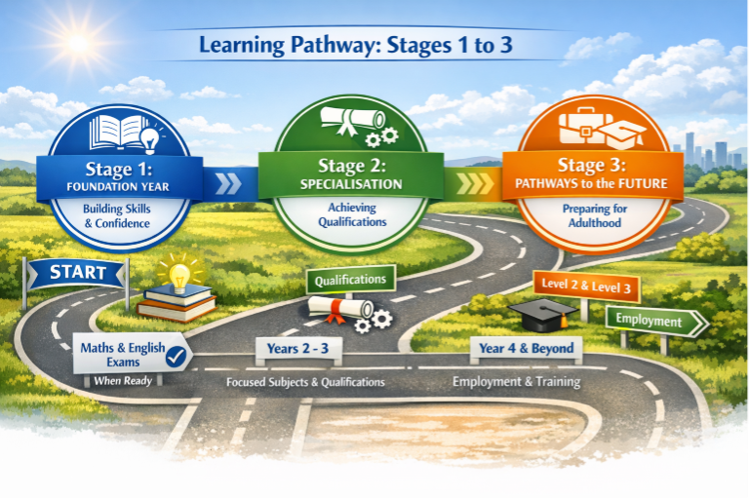

Preparation for Adulthood
At Bankside College, Preparation for Adulthood is not a standalone strand—it is the heartbeat of our curriculum. Every student’s pathway is designed with care, ambition, and authenticity, ensuring that learning is not only meaningful but transformative. We recognise that for many of our learners, the journey to adulthood has been marked by disruption, uncertainty, or trauma. Our role is to rebuild confidence, restore agency, and scaffold success—step by step.

Each student follows a personalised pathway that includes:

- Independent Living Skills:
From budgeting and meal preparation to travel training and personal care, students engage in practical, real-world learning that promotes autonomy and dignity. A student might learn to navigate public transport using visual maps, practise laundry routines in our life skills suite, or plan a weekly shop using digital tools. These experiences are structured, supported, and celebrated.
- Employability Training:
We offer tailored work-related learning that reflects each student’s interests and strengths. This includes CV writing, interview preparation, workplace etiquette, and supported internships. Students might run a provision at College or take part in external placements with trusted partners. Every opportunity is framed by clear expectations and kind encouragement.
- Community Engagement:
Students are supported to participate meaningfully in their communities—whether through volunteering, accessing local services, or contributing to social action projects. A group might plan a litter-picking initiative, visit a local museum, or collaborate with a charity to raise awareness. These experiences foster connection, citizenship, and pride.
- Carefully Selected Qualifications:
We offer a range of accredited and non-accredited qualifications that are purposeful, motivating, and relevant to each learner’s goals. Whether pursuing Entry Level Functional Skills, BTEC vocational awards, or bespoke enrichment awards, students are guided to achieve success in ways that feel personal and empowering.

Preparation for Adulthood at Bankside College is not just about ticking boxes—it’s about building futures. Through consistent routines, kind relationships, and aspirational planning, we help every student move forward with confidence, capability, and hope.

Teaching and Learning

At Bankside College, teaching is more than instruction—it’s a relationship built on trust, creativity, and care. We embrace a wide range of teaching styles to ensure every student feels engaged, understood, and empowered to progress. Lessons are thoughtfully structured with clear objectives, personalised activities, and reflective conclusions that honour each learner’s journey. Our lesson CRAFT focuses on 10 key principles:
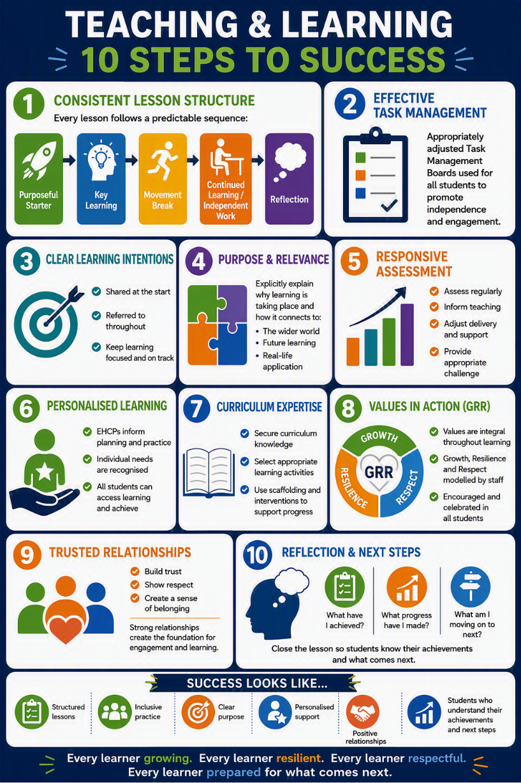

Furthermore, we ensure that:
- Tasks match ability and learning style:
Every activity is tailored to meet students where they are. A student who thrives with hands-on learning might explore numeracy through cooking measurements, while another who prefers visual cues might use pictorial sequences to understand time management. Differentiation is not just a strategy—it’s a promise of inclusion.
- Open-ended challenges encourage depth:
Students are invited to think beyond the surface. In a project on community, one student might design a poster campaign, another might write a poem, and a third might create a digital presentation. These open-ended tasks foster ownership, creativity, and pride.
- Practical, visual, and supported learning:
Whether building a birdhouse in vocational studies or exploring emotions through role-play in PSHE, we use tactile and visual methods to bring learning to life. Learning Support Mentors offer consistent encouragement and scaffolding, ensuring no student feels left behind.
- Trips and visitors enrich understanding:
Real-world experiences deepen connection and relevance. A visit to a local farm might spark a science unit on habitats, while a guest speaker from a charity could inspire a social action project. These moments extend learning beyond the classroom and into the heart of the community.
- Communication systems and assistive technology enhance access:
We use a range of tools—from PECS and Makaton to speech-to-text software and interactive whiteboards—to ensure every student can participate fully. Technology is not a substitute for connection—it’s a bridge to it.

Every lesson at Bankside College is delivered through the enactment of our values of growth, resilient & respect. This means students know what to expect, feel safe to take risks, and trust that their efforts will be met with encouragement and respect. In this environment, learning becomes not just possible—but joyful.

Enhancing the Teaching and Learning

Key Skills

At Bankside College, we believe that empowering students with essential life and learning skills is the foundation for building incredible futures. Our curriculum is designed to nurture the whole person, with a consistent focus on growth, dignity, and opportunity. We embed the following core skill areas across all learning experiences:
- Communication: Students are supported to express themselves confidently and appropriately, using spoken language, written formats, visual aids, or assistive technology. Whether it's sharing ideas in a group project or advocating for their own needs, communication is celebrated as a gateway to independence.
- Problem Solving: Through real-world challenges—like planning a community event or navigating a travel route—students learn to think critically, explore options, and make informed decisions. Staff model calm, consistent approaches to problem solving, encouraging resilience and creativity.
- Reflective Learning: We help students become aware of their own progress and learning styles. Reflection journals, peer feedback, and one-to-one mentoring sessions allow students to recognise their achievements and identify next steps with kindness and clarity.
- Collaboration: Teamwork is woven into every aspect of college life. From group cooking sessions to enterprise projects, students learn to listen, contribute, and compromise. Staff ensure group dynamics are inclusive and respectful, modelling visible kindness in every interaction.
- Independent and Creative Thinking: Students are encouraged to explore their passions and think beyond the obvious. Whether designing a sensory garden or writing a personal story, we provide space for imagination and autonomy, always guided by consistent support.
- Planning and Organisation: Structured routines and visual timetables help students develop executive functioning skills. From managing a weekly budget to preparing for work experience, students learn to plan ahead and take ownership of their responsibilities.

Learning at Bankside College is never one-size-fits-all. It is meaningful, realistic, and tailored to each student’s goals.
Curriculum Planning and Personalisation
At Bankside College, learning begins with the individual. We recognise that every young person arrives with a unique story, a distinct set of strengths, and a personal pathway to success. Our curriculum is designed to honour that individuality—making learning meaningful, relevant, and empowering.
To ensure coherence and progression, we plan our curriculum in three distinct phases:
Long-Term Planning: Sequences of Learning
Long-term planning provides the strategic framework for each curriculum area. Subject Leaders prepare an overview that outlines the key topics, core skills, and thematic ‘seeds’ that will inspire learning across the term.
These sequences ensure that:
- Core skills are embedded across subjects to promote transferable learning.
- Curriculum coverage is mapped clearly, ensuring breadth, depth, and progression.
These overviews are used to guide their planning, adapting content to meet the needs of their students while maintaining a consistent structure. Teachers are encouraged to make learning sequential, but always purposeful and responsive to the individual.

Medium-Term Planning: Structuring Learning
Medium-term plans provide the bridge between strategic intent and classroom delivery. These plans offer guidance on lesson objectives, teaching strategies, and resource use across the term.
Teachers identify a sequence of core lesson objectives for each subject, ensuring that learning builds logically and meaningfully. Flexibility is encouraged—staff may choose to block or stagger lessons to suit the rhythm and interests of their class.
Planning is supported by:
- Detailed units of work
- Qualification assessment criteria
- EHCP targets and outcomes
- Therapeutic goals and regulation strategies
This phase ensures that learning remains structured, inclusive, and aligned with each young person’s developmental profile.
Short-Term Planning: Personalised Weekly Plans
Short-term planning is where personalisation comes to life. Each class teacher creates weekly plans tailored to the learners they support, ensuring that every session is intentional, adaptive and engaging.
Weekly plans include:
- Specific learning goals and success criteria, showing clear progression across the week
- Core learning objectives and key skill areas,
- Outline of teaching input, including strategies for engagement, regulation, and scaffolding
- Adaptive tasks for individuals and groups, ensuring accessibility and challenge
- Assessment opportunities, including formative feedback and reflection
These plans are living documents—responsive to student voice, therapeutic needs, and emerging interests. They reflect our commitment to our values of growth, resilience and respect in delivery, ensuring that every young person feels safe, supported, and inspired to grow.
Progression and Continuity in the Curriculum
At Bankside College, we are deeply committed to ensuring that every student experiences a coherent, purposeful, and progressive learning journey.

We achieve progression and continuity in the curriculum through:
- Use of Planning Documentation:
Teachers follow clearly structured long-, medium-, and short-term planning frameworks that ensure learning is sequenced, relevant, and responsive to individual needs. These documents provide a shared language and vision across the college, allowing staff to build on prior knowledge and scaffold future learning with consistency.
- Regular Planning Team Discussions:
Weekly planning meetings bring teaching teams together to reflect, refine, and align their approaches. These sessions are collaborative and supportive, offering space to share successes, troubleshoot challenges, and uphold high standards. Staff are encouraged to bring examples of student work, discuss differentiation strategies, and celebrate progress—reinforcing a culture of kindness and professional growth.
- Assessment for Learning and Record Keeping:
Ongoing formative assessment is embedded in every lesson. Staff use questioning, observation, and student self-reflection to gauge understanding and adapt teaching in real time. Records are maintained with care and clarity, ensuring that each student’s journey is documented and celebrated. Feedback is delivered with warmth and precision, helping students understand their next steps and feel proud of their achievements.
- Moderation of Standards Across Teams:
Regular moderation activities ensure consistency in expectations and fairness in assessment. Staff review samples of student work together, discuss grading criteria, and agree on benchmarks for progress. These sessions promote shared accountability and mutual respect, reinforcing our commitment to equity and excellence.

Through these practices, we create a curriculum that is not only structured and progressive, but also compassionate and inclusive—where every student is known, valued, and supported to thrive.

Assessment Reporting on Student Attainment
At Bankside College, assessment is not just a measure of progress—it’s a celebration of growth, a tool for empowerment, and a reflection of our unwavering commitment to our young people's hollistic development. We assess with purpose, and we feed back with compassion, ensuring every student feels recognised, understood, and supported.
We assess learning through:
- Setting and Reviewing Termly PLP Targets:
Each student has a personalised learning plan (PLP) that reflects their unique strengths, needs, and aspirations. Targets are co-created with students, families, and professionals, and reviewed termly to ensure they remain relevant and achievable. These reviews are moments of reflection and encouragement, not pressure.
- Tracking Progress:
Progress is monitored through tailored assessments, classroom observations, and student portfolios; we track and celebrate every step forward with clarity and care.
- Encouraging Self and Peer Evaluation:
Where appropriate, students are invited to reflect on their own learning and offer feedback to peers. This builds metacognition, empathy, and ownership. A student might use a visual scale to rate their confidence after a presentation, or share what they admired in a peer’s artwork—fostering a culture of mutual respect.
We report progress through:
- Feedback to Parents and Carers: This takes place in the form of fortnightly emails, family afternoons, phone calls and formal certificates. We believe that this variety and regularity of communication is more conducive with personal development and relationship building.
- EHCP Reviews with Educational Input: Each year, students’ Education, Health and Care Plans are reviewed in collaboration with families and professionals. Our educational reports are detailed, honest, and hopeful—ensuring that every voice is heard and every need is addressed.
- Regular Updates to the Governing Body: Governors receive termly data and narrative reports that reflect whole-college progress, emerging trends, and strategic priorities. These updates ensure accountability and celebrate the collective impact of our teaching and support teams.
At Bankside College, assessment is a shared experience—one that honours effort, guides growth, and strengthens relationships. Through consistent practice and kind communication, we ensure that every student knows: their progress matters, their voice is valued, and their future is bright.
Target Setting
At Bankside College, setting ‘next learning steps’ is a dynamic, compassionate process that ensures every student’s journey is purposeful, personalised, and celebrated. We don’t just track progress—we scaffold it. Every step forward is guided by clear evidence, thoughtful reflection, and a deep understanding of the learner’s needs and aspirations.

We set next learning steps through:
- Marking and Feedback:
Feedback is delivered with clarity and kindness, helping students understand what they’ve achieved and where they’re heading next. Whether through annotated work, verbal praise, or visual cues, our feedback is consistent, affirming, and tailored to each learner’s communication style.
- Baseline and Attainment Data:
We use initial assessments and ongoing attainment tracking to identify starting points and monitor growth. This data informs planning, differentiation, and intervention, ensuring that learning remains ambitious and achievable.
- Literacy and Numeracy Tracking:
Core skills are tracked using differentiated frameworks that reflect each student’s pathway. From early phonics and functional number work to applied literacy in vocational contexts, we ensure that progress is visible, celebrated, and linked to real-world outcomes.
- Evidence for Learning (EfL):
Our digital assessment platform, Evidence for Learning, allows staff to capture progress in real time through photos, videos, and annotations. These observations are directly linked to PLP targets, curriculum objectives, and EHCP outcomes, creating a rich, accessible record of achievement. Students and families can view and contribute to this journey, strengthening transparency and trust.
- EHCP Target Reviews:
EHCP outcomes are reviewed regularly and inform every aspect of curriculum planning. Staff use EfL to gather evidence against these targets, ensuring that next steps are not only educationally sound but also aligned with each student’s broader developmental goals. Reviews are collaborative, respectful, and rooted in lived experience.

At Bankside College, next steps are never generic—they are intentional, inclusive, and infused with our values. We guide students forward with structure and care, ensuring that every learner knows: your growth is recognised, your goals are achievable, and your future is worth investing in.

Monitoring, Leadership and Community Engagement

At Bankside College, curriculum leadership is strategic, compassionate, and deeply rooted in our commitment to our vision. The Headteacher oversees curriculum delivery with clarity and vision, supported by the Deputy Headteacher and the wider leadership team, who ensure operational alignment and pedagogical rigour across all pathways.

Monitoring is not a checklist—it is a relational and reflective process that celebrates strengths, identifies areas for growth, and ensures every student receives the highest quality of education. Our approach includes:
- Regular Learning Walks with Focused Themes:
Senior leaders conduct regular learning walks that explore specific themes—such as differentiation, communication strategies, or trauma-informed practice. These walks are collaborative and affirming, offering real-time feedback and celebrating effective teaching. Staff know what to expect and feel supported in their development.
- Work Sampling and Attainment Reviews:
Samples of student work are reviewed across subjects and pathways to ensure consistency in standards and progression. These reviews are used to highlight best practice, refine planning, and ensure that assessment is purposeful and inclusive.
- Evaluation of Teaching Impact:
Teaching is evaluated not just by outcomes, but by the quality of relationships, engagement, and learner voice. Observations and feedback focus on how well students are supported to thrive—academically, socially, and emotionally.

These moments of connection reinforce trust, transparency, and shared pride in each student’s journey.
At Bankside College, leadership is visible, supportive, and values-driven. Monitoring is consistent, kind, and focused on impact. And our community partnerships are built on mutual respect and a shared belief in every learner’s potential.

Equalities and Representation
We follow Safer Recruitment and equal opportunities practices. We actively reduce barriers and promote inclusion. Curriculum content highlights role models who have overcome adversity, celebrating diversity in age, ethnicity, gender, and background.

Closing Statement
At Bankside College, our curriculum is more than a framework—it’s a reflection of who we are. It is designed to challenge, be age-appropriate and focus on learners thriving in educational, social, and enrichment activities.

